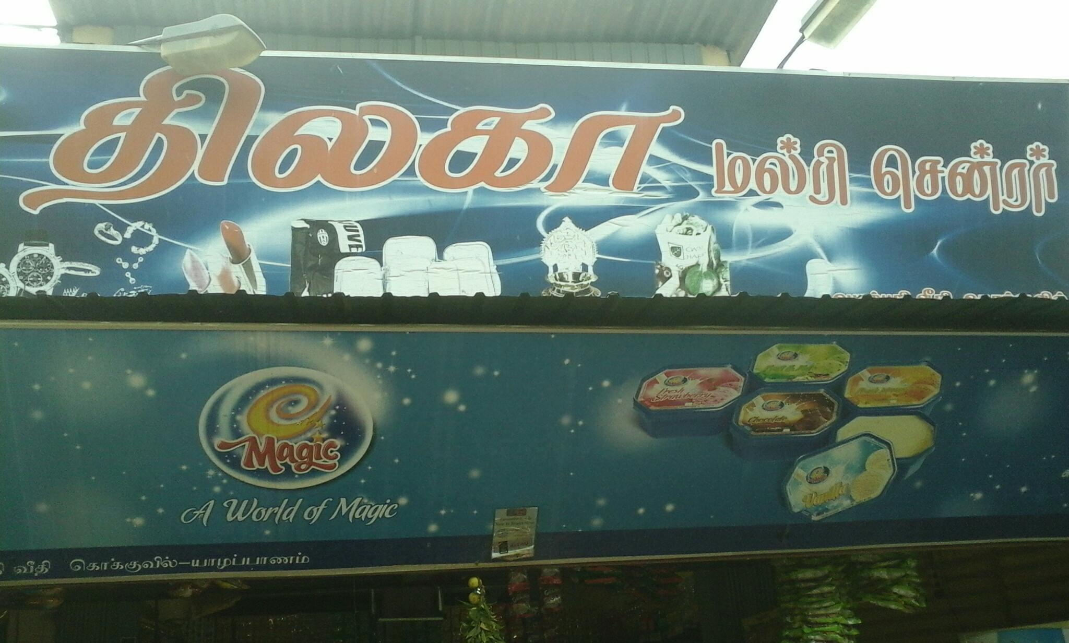

**THILAKA MULTI SHOP**

**STOCK MANAGEMENT SYSTEM**

**GROUP-O**

# Declaration of Authorship

We Mr.A.Thushanthan, Mr.A.Aravinthan, Mr.A.Venuraj, Mr.P.Lanojan are here by certifying that this project titled “**Stock Management System**” is entirely our own work. It has been not submitted or it is not being concurrently submitted for any other degree.

……………………………………… A.Thushanthan(2013/CSC/023)

……………………………………… A.Aravinthan (2013/CSC/021)

………………………………………

A.Venuraj (2013/SP/041)

………………………………………

P.Lanojan (2013/CSC/016)

………………………………………

Supervisor,

Dept of Computer Science,

Faculty of Science.

………………………………………

Head of the dept,

Dept of Computer Science,

Faculty of Science.

# Contribution of each member

A.Thushanthan

He gave the idea to do this stock management system for our software engineering course unit.

He is good in C# and he took a main part for develop the billing system in the short time interval and also help to build the project.

P.Lanojan

He helped to get the customer.

He is good in interface development and he took a part for creating interface and help to solve some problem in the code developing part.

A.Venuraj

He is good in MySQL and he took a major part in connecting sql server to visual studio, develop the login page and data entry to the sql.

A.Aravinthan

He also a good interface developer and he took a part for developing a colourful interface and also help to solve some problem in the coding part.

# Consent of the Client

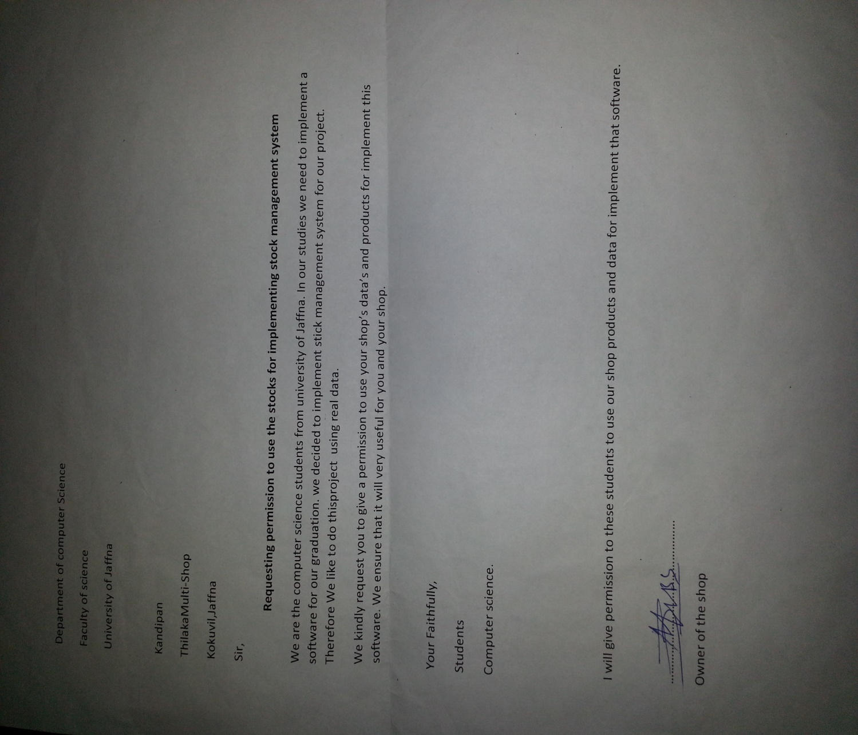

# Table of Content

Declaration of Authorship 2

Contribution of each member 3

Consent of the Client 4

Table of Content 5

Introduction 6

Purpose of the project 6

Overview of the document 6

Requirements Specifications 7

Software Design 8

Use case Diagram 8

Sequence Diagram 9

Software Design 11

Implementation 15

Tools, Techniques and Justification 15

Special Features 15

Discussions and challenges 18

References 18

Appendices 18

# Introduction

## Purpose of the project

Stock management system is everywhere. Big shopping malls, Food cities, Super markets already have a stock management system. But srilankan economy is very poor. Most of the shops in srilanka don’t have a proper stock management system. Therefore our group decided to solve this problem and we finalize our project as stock management system and also we didn’t target the big shop , we consider only the small shop and we provide our software for free and make an awareness about importance of computer technology in the world.

## Overview of the document

In this documentation we consider about gathering requirements and the problem we met when gathering the information, software designs and the model graphs, special features in our software, the technical and physical challenges we met when implement the software and the references we use.

# 

# Requirements Specifications

In the requirement collection we first deal with our customer .we first asked what they need. Then we decided what are the requirements we need and we collect them from our customer. We collect some bills from the shop for summarize our project and made a plan.

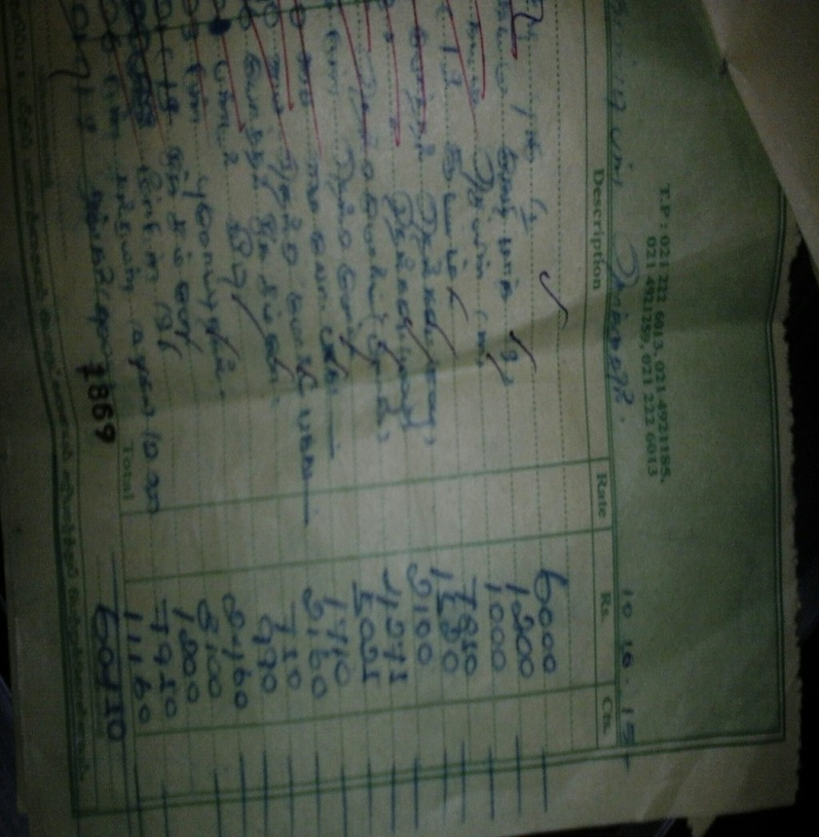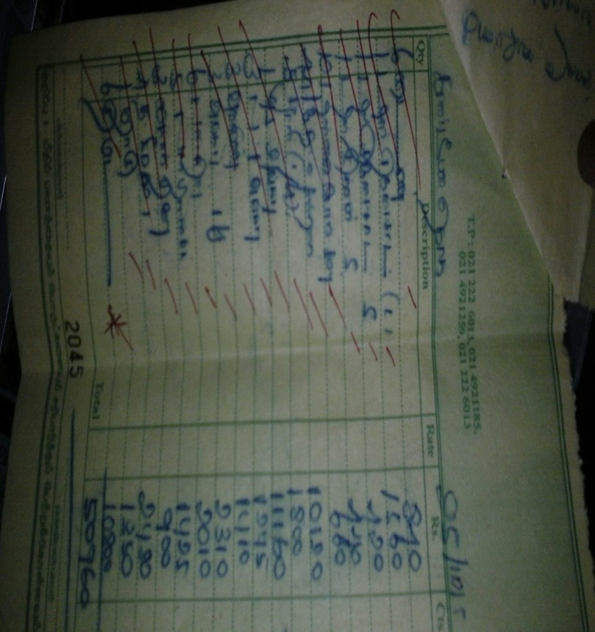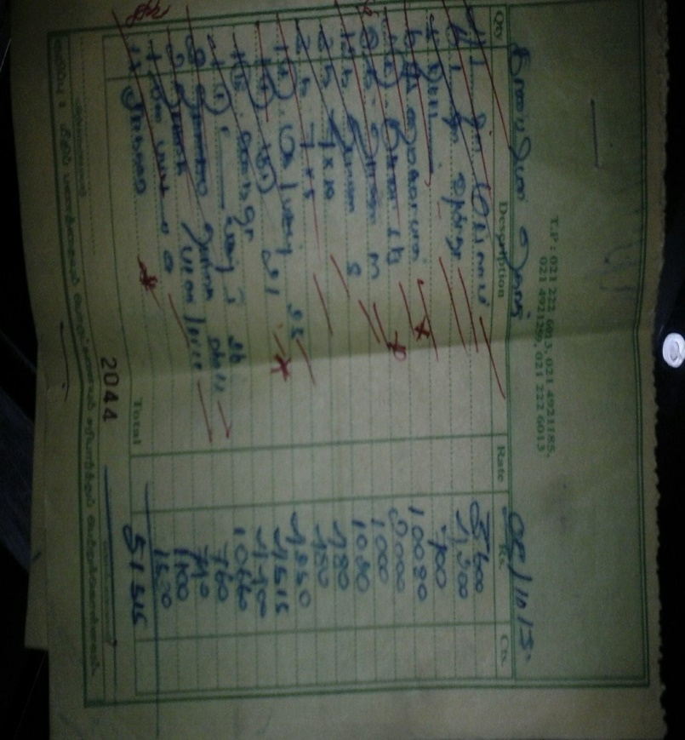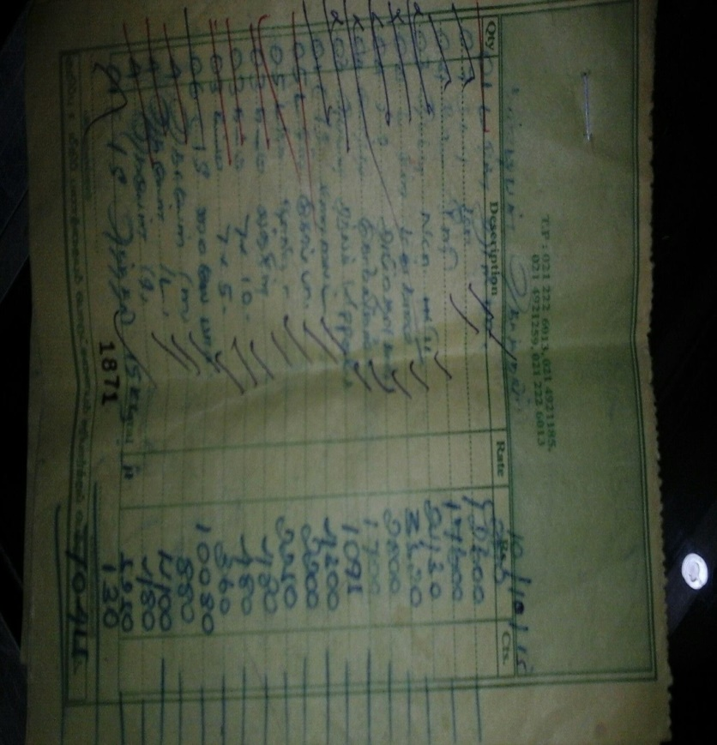

# Software Design

## Use case Diagram

|  |  |  |
| --- | --- | --- |
| Admin | Change Password  Summary  Update New Items  Insert New Item  Billing  Login | Worker |

## Sequence Diagram

|  |  |  |  |
| --- | --- | --- | --- |
| customer | Admin | Software | Worker |
|  | Select User | Type username  Type password  Shows Options  Choose Add nee product  Insert product id().  Insert Product Name().  Insert Product Price().  Insert Product Quantity().  Select Expired date().  Select Back to main. | Select User |
|  |
| Choose Update the Products.  Insert product id().  Insert Product new price().  Insert new product quantity().  Select expired date. |
| Select submit. |
| Select back to main.  Choose summary.  Shows the summary  Select back to main.  Choose change password. |
| Ask to login. |
| Change the password.  Back to main. |
| Choose billing.  Insert product id().  Insert product name.  Insert price().  Insert quantity().  Select date  Select submit.  Type money paid.[Balance>0]  Shows purchase amount, balance. | Choose billing |
|  |
| Order items  Give money |
| Handover recipt.  Handover balance.  Handover item |
| Take balance.  Take items. |

## Software Design

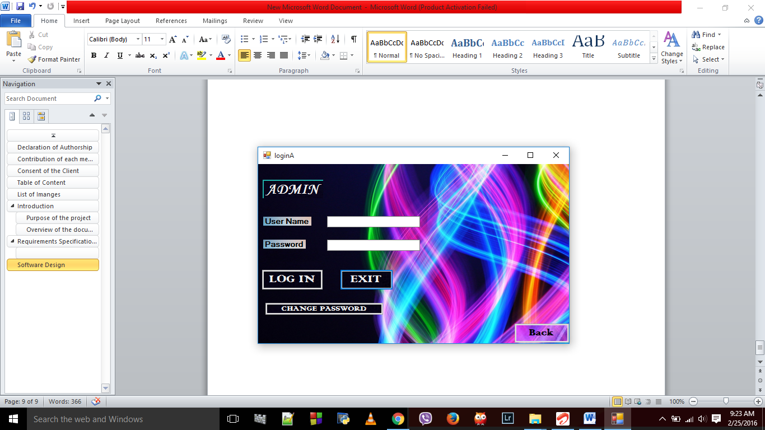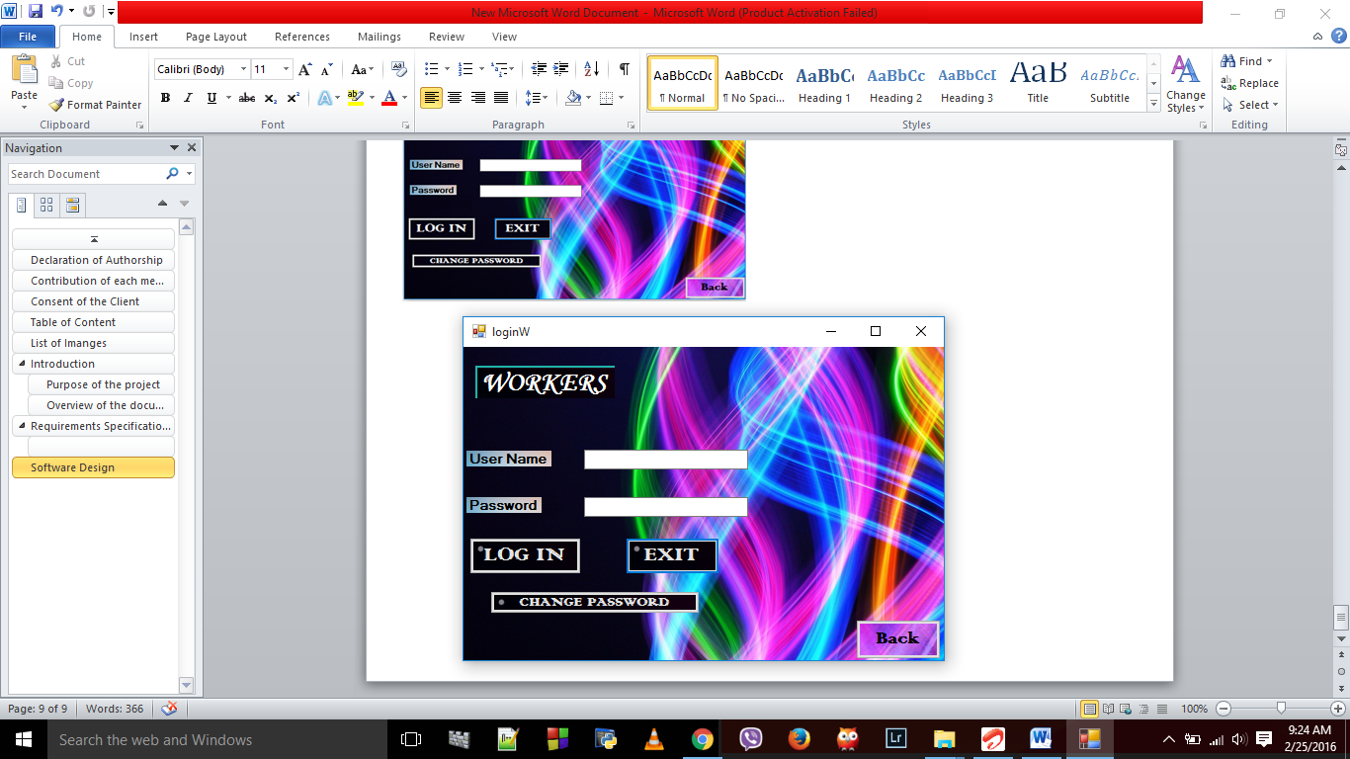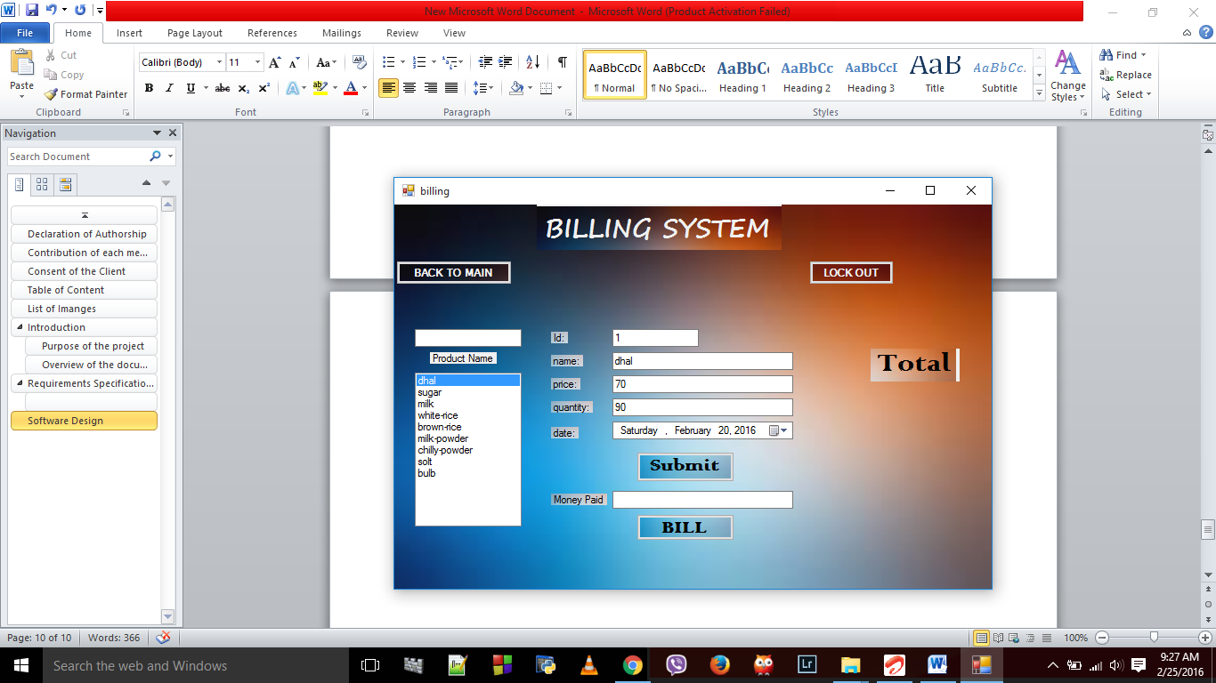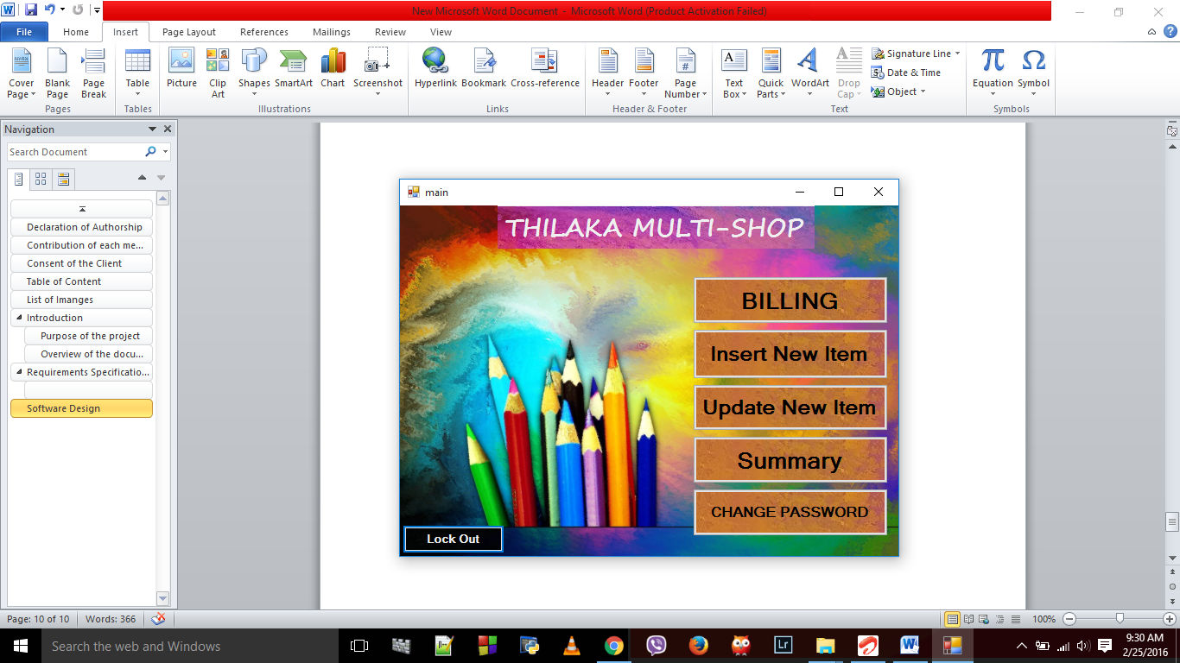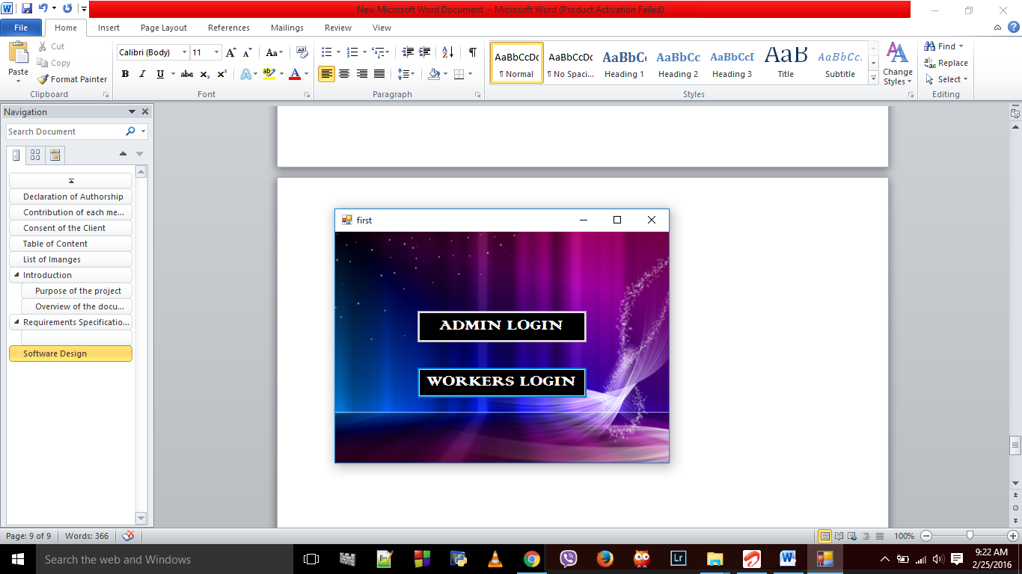

**Enter Correct User Name and Password then click Login**

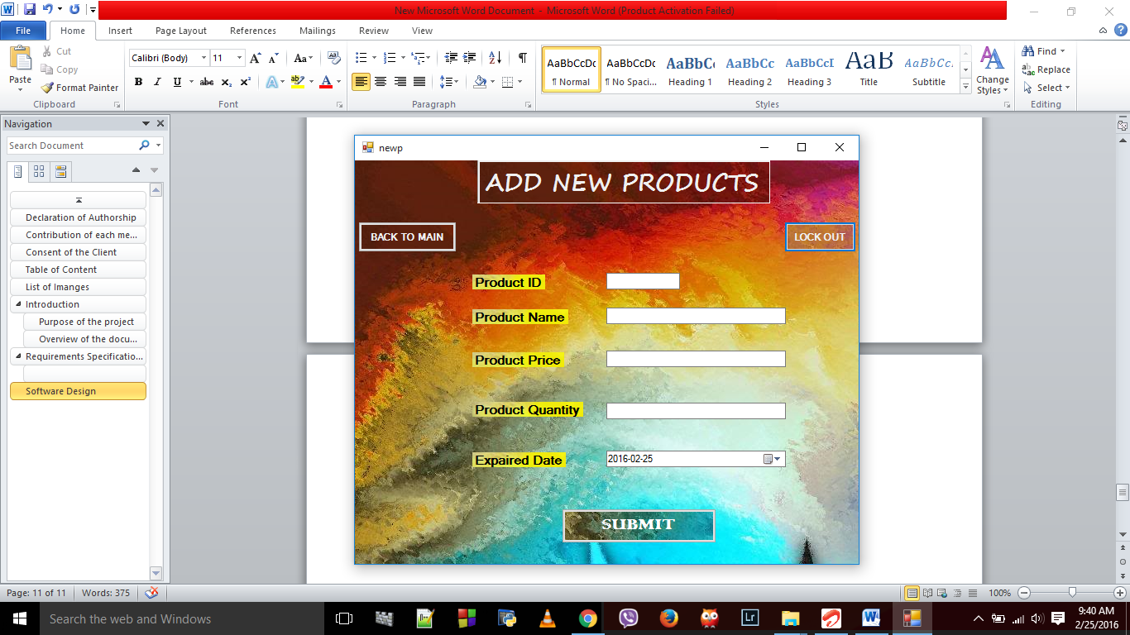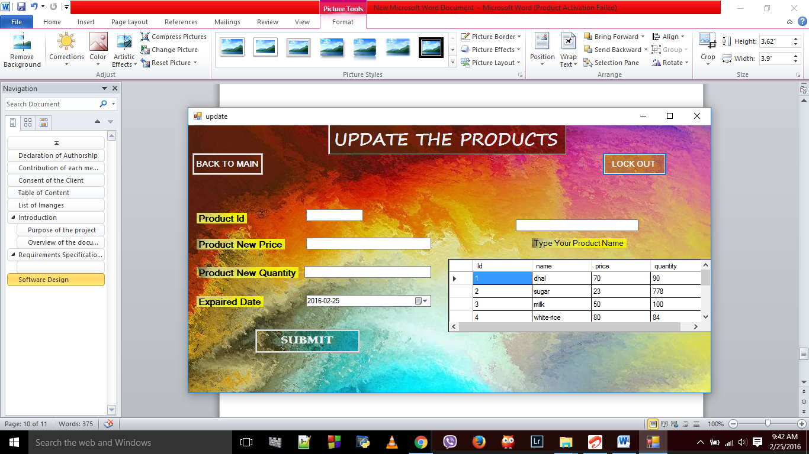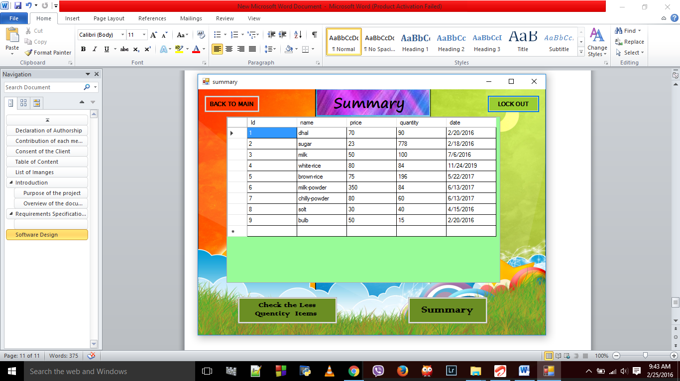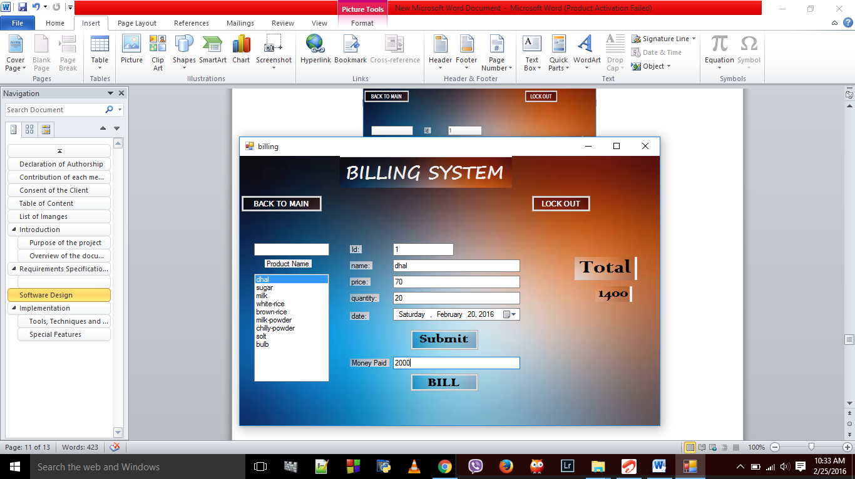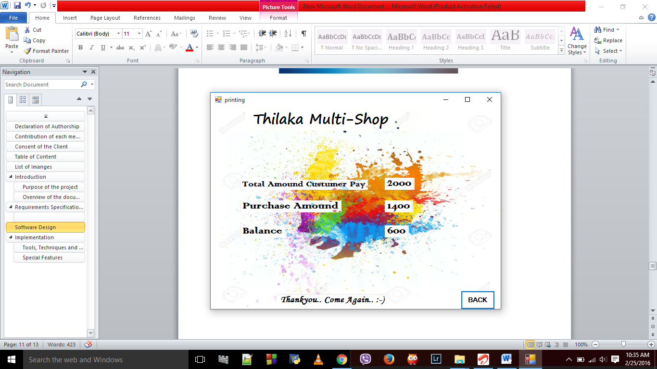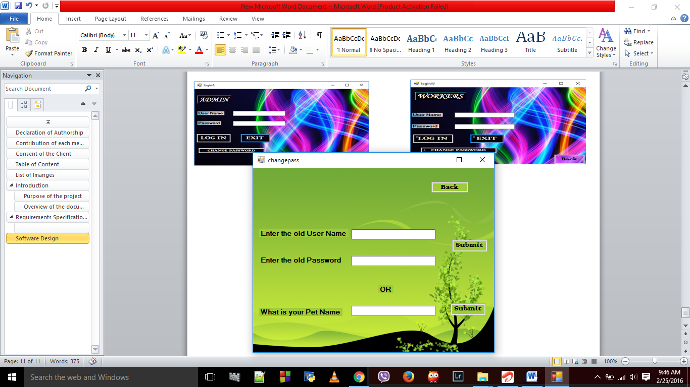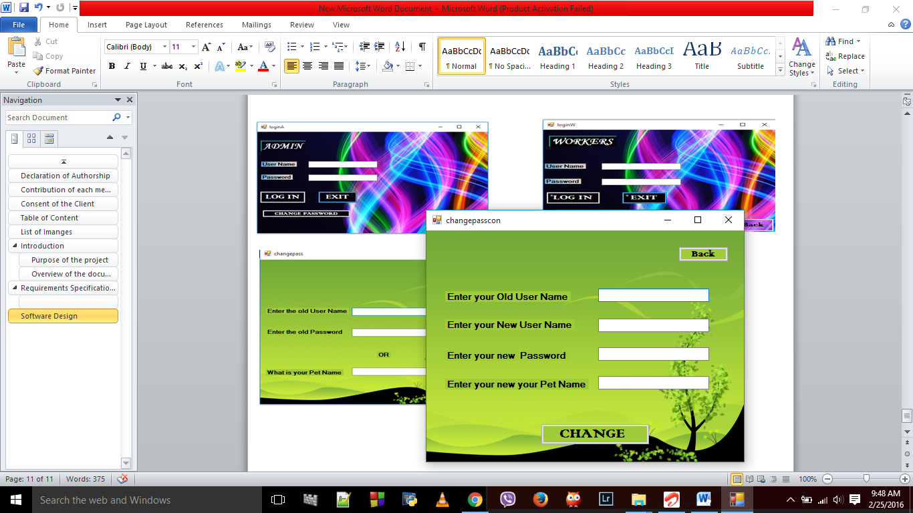

**Click Change Password**

**Click Change Password**

**Directly goes here**

# Implementation

## Tools, Techniques and Justification

* In here we use visual studio for implement this software . In the visual studio we use C# language to implement this program.
* We used mysql server to store the data.

## Special Features

* Every time Admin login his page if the quantity of the product less than 50 it will automatically show some message to refill the quantity.

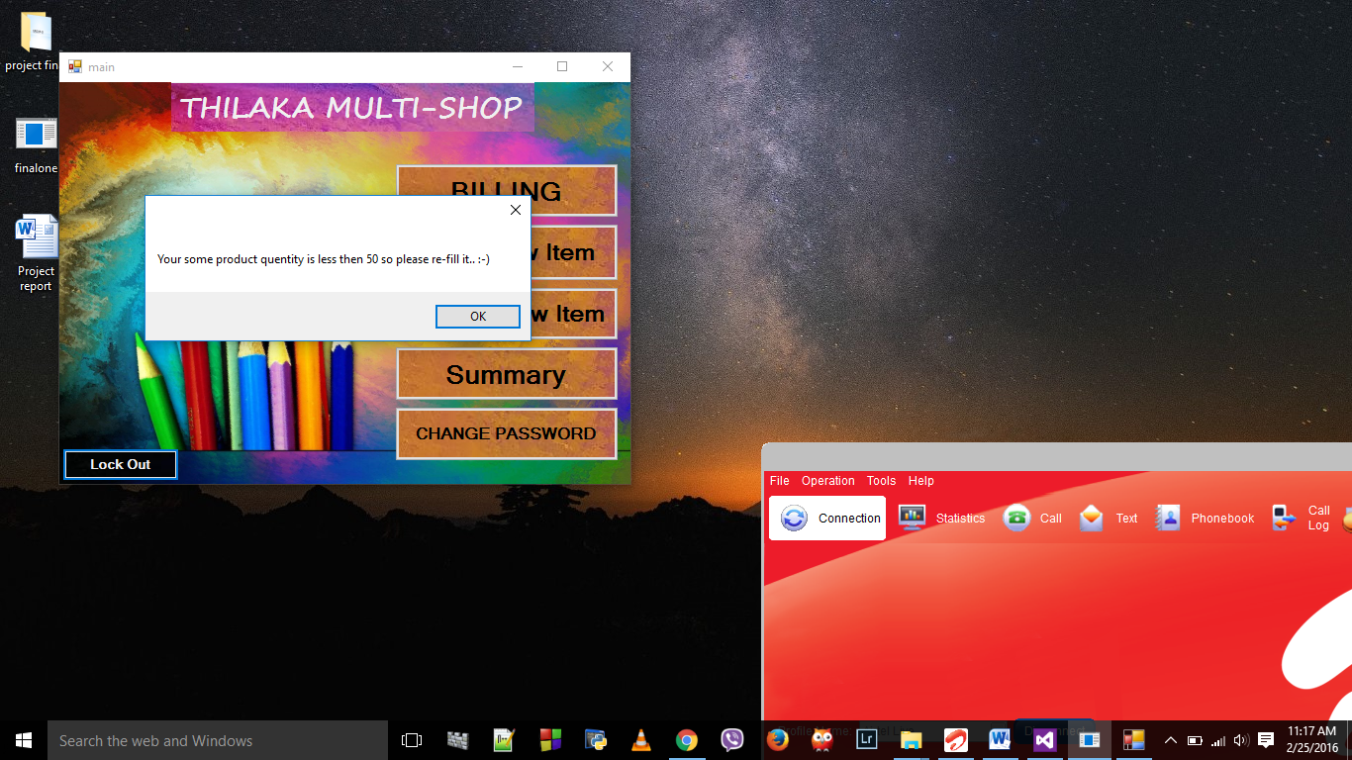

* In the Summary we can easily find the products which are less than 50 in its quantity .

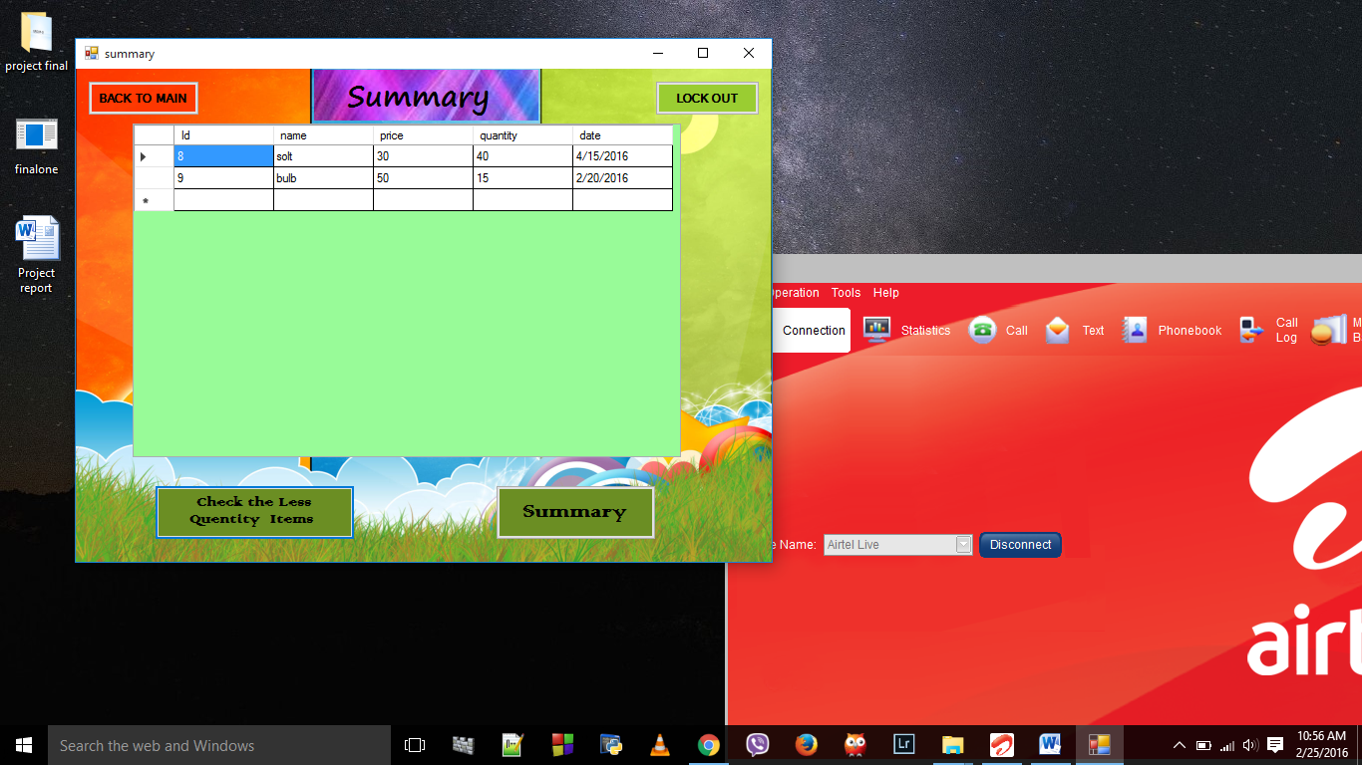

* In the update we easily find the product id by typing the product name in the left side.

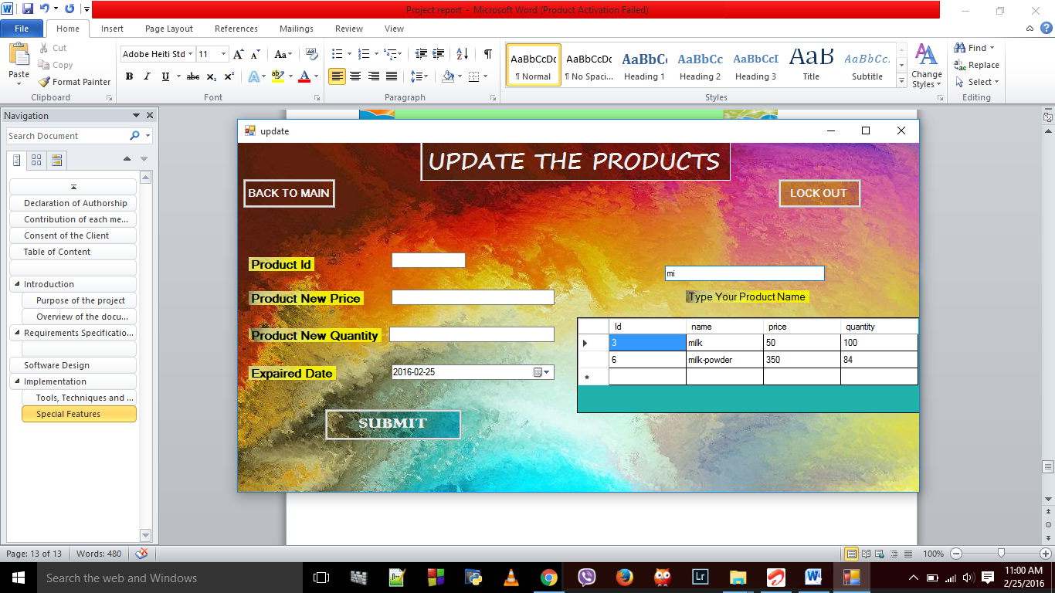

* In the Billing system we can easily find all the details about the product by typing the product name in the left side text box. Specially it will show the expired date ,so the seller assure the product can be used.

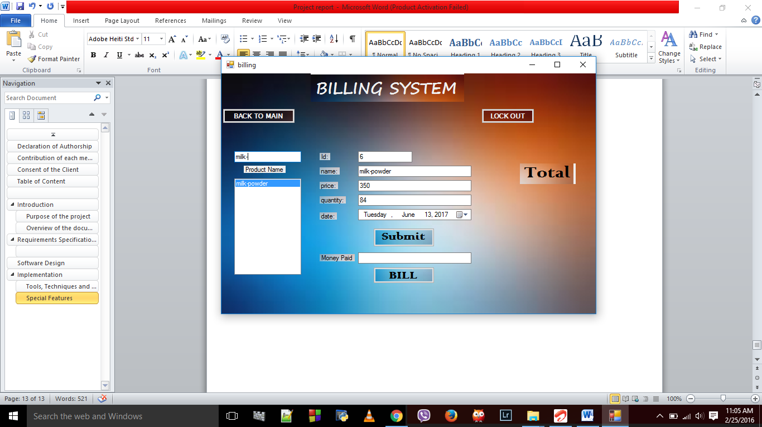

* In the forgot password, sometime if we forgot the username and password then it has a another option called pet name. We can type the pet name and easily change the username and password.

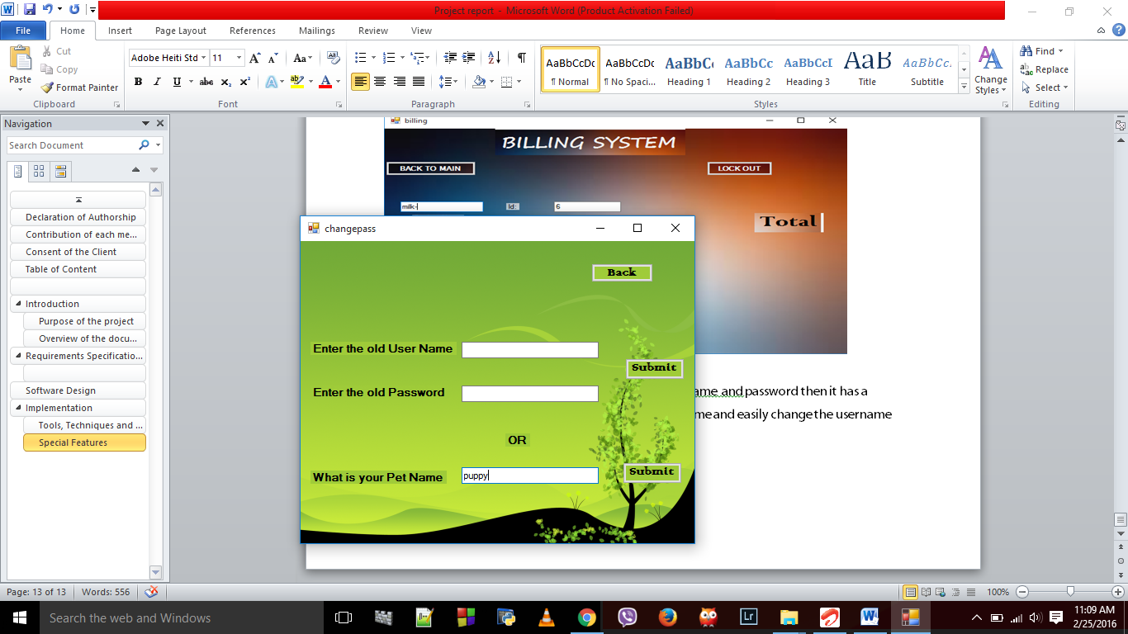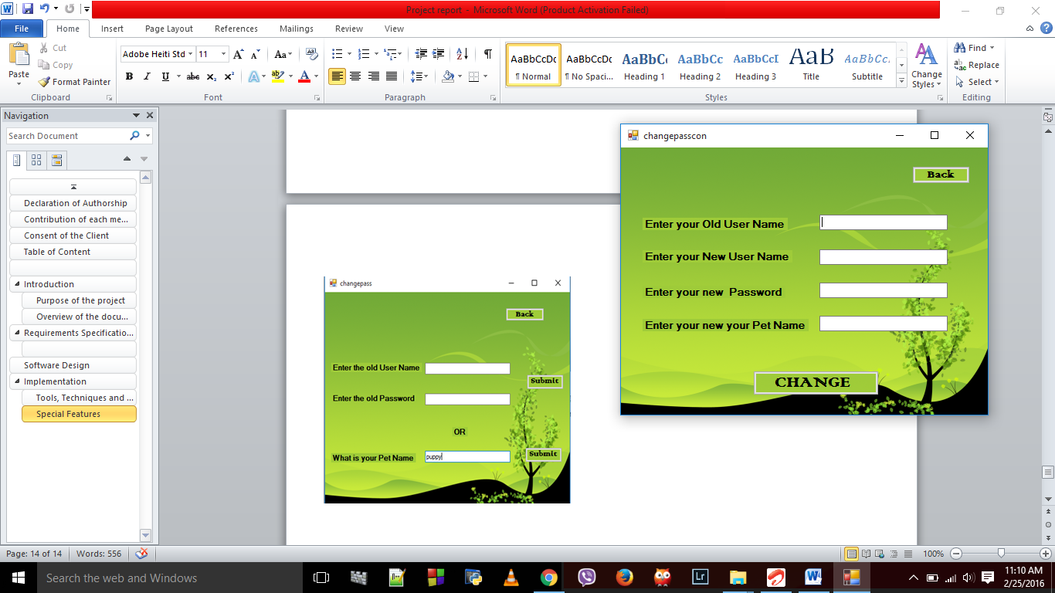

# Discussions and challenges

We have a challenge came from selecting a project and finally with many analysis we decided to do a stock management system for a small shops for free.

We have a challenge came from selecting a platform what we use, then we decided to do the project using visual studio C#. We are starters for visual studio so it is little hard and give a new experience for us.

We have some technical and cording problem occurred and by using internet we solve the problems.

Sometime the cording is correct but there are some bugs occurred.

# References

* Watching some YouTube videos.
* We got some coding from internet.
* We got some help from our demonstrators.
* We get some ideas from our seiners

# Appendices

Need a copy of our software please contact

A.Thushanthan - thushaamal93@gmail.com